**ASSIGNMENT 1**

**MOTHERBOARD**

The motherboard is a main printed circuit. It is also called the main circuit board or mainboard. It includes several components on a single platform. It allows communication between the RAM, ROM, hard drive, and other computer hardware components. The motherboard is also called the backbone of a computer.

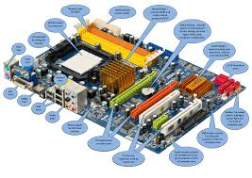

**RAM MODULES**

RAM (Random Access Memory) modules are essential components in computers that provide temporary storage for data and programs currently in use, allowing for quick access and processing. They come in various types, including DDR (Double Data Rate) variants like DDR3, DDR4, and DDR5, each offering different speeds and capacities. RAM modules are typically installed in DIMM (Dual Inline Memory Module) slots on the motherboard. The amount and speed of RAM significantly impact a system's performance, especially in multitasking and memory-intensive applications.

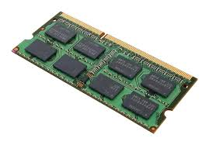

**Daughter cards**

Daughter cards, also known as daughterboards, are circuit boards that attach to a main motherboard to provide additional functionality or features. They enhance a system's capabilities, such as adding graphics, network connectivity, or specialized processing. Daughter cards connect via various interfaces, like PCIe or proprietary connectors, allowing for modular upgrades. Their use promotes flexibility and cost-effectiveness, as users can replace or upgrade specific components without changing the entire system. Common applications include graphics cards, sound cards, and network interface cards. Overall, daughter cards facilitate customization and expansion in electronic devices.

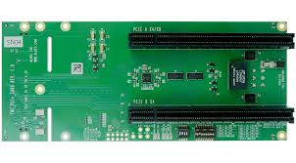

**BUS SLOTES**

Bus slots are physical connectors on a motherboard that allow expansion cards, such as graphics cards, sound cards, and network interface cards, to be added to a computer system. They facilitate communication between the motherboard and the attached devices by providing a pathway for data transfer. Common types of bus slots include PCIe (Peripheral Component Interconnect Express), PCI (Peripheral Component Interconnect), and AGP (Accelerated Graphics Port). Each type varies in speed, bandwidth, and intended use, with PCIe being the most prevalent in modern systems. Bus slots enable modularity, allowing users to upgrade or customize their systems easily. Overall, they play a crucial role in expanding a computer's capabilities.

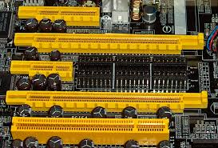

**SMPS**

A Switch Mode Power Supply (SMPS) is an electronic power supply that efficiently converts electrical power using switching regulators to control the output voltage. Unlike traditional linear power supplies, SMPS operates by rapidly switching the input voltage on and off, which reduces energy loss and improves efficiency. It can provide various output voltages and is commonly used in computers, televisions, and other electronic devices. SMPS units are compact and lightweight compared to linear power supplies, making them ideal for modern applications. They also include features like over-voltage protection and short-circuit protection for safety. Overall, SMPS is essential for delivering reliable and efficient power to electronic components.

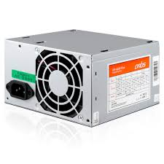

**INTERNAL STORAGE DEVICES**

1. **Hard Disk Drives (HDD)**: Traditional magnetic storage devices that use spinning disks to read and write data. They offer large storage capacities (hundreds of GB to several TB) but are slower than SSDs, with average speeds around 80-160 MB/s.

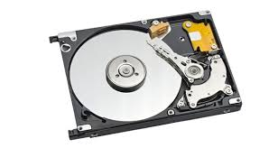

1. **Solid State Drives (SSD)**: Storage devices that use flash memory with no moving parts, providing faster data access and transfer speeds (often exceeding 500 MB/s). They range from 120 GB to several TB in capacity and are ideal for operating systems and applications.

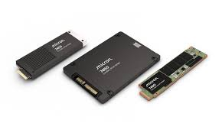

1. **Hybrid Drives (SSHD)**: Combine HDD and SSD technologies, featuring a traditional spinning disk with a small SSD cache. They provide a balance of large storage capacity and improved speed for frequently accessed data.

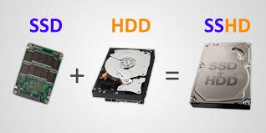

1. **SATA SSDs:** A type of solid-state drive that connects via the SATA interface. While slower than NVMe SSDs, they still offer significant speed improvements over HDDs and are widely used for upgrading older systems.

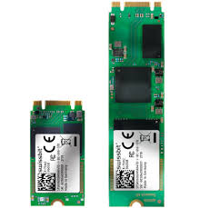

1. **Tape Drives**: Although less common in consumer devices, tape drives are used for archival storage in enterprise environments. They provide high-capacity storage for backup and long-term data retention, though access speeds are slower compared to HDDs and SSDs.

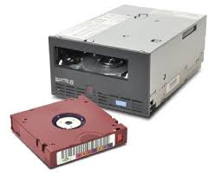

1. **Optical Drives**: Internal CD, DVD, or Blu-ray drives that read and write data on optical discs. While their use has declined with the rise of digital downloads, they are still found in some desktops and laptops for media playback and data storage.

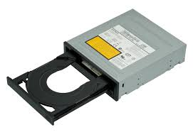

**INTERFACE PORTS**

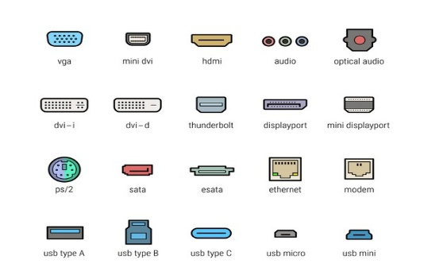

1. **USB (Universal Serial Bus)**: A widely used interface for connecting peripherals such as keyboards, mice, printers, and external storage devices. USB ports come in various versions (USB 2.0, 3.0, 3.1, and USB-C), with newer versions offering faster data transfer rates and improved power delivery.
2. **HDMI (High-Definition Multimedia Interface)**: A digital interface used to transmit high-definition video and audio from devices like computers, TVs, and gaming consoles to displays. HDMI supports various resolutions and audio formats, making it a standard for home entertainment systems.
3. **Ethernet (RJ-45)**: A port used for wired network connections, allowing devices to connect to local area networks (LANs) and the internet. Ethernet ports support various speeds, including Fast Ethernet (100 Mbps) and Gigabit Ethernet (1 Gbps).
4. **DisplayPort**: A digital display interface primarily used to connect a computer to a monitor. It supports high resolutions and refresh rates, making it suitable for gaming and professional applications. DisplayPort can also carry audio and is capable of daisy-chaining multiple monitors.

**Desktop Class Computer Specifications**

1. **Processor (CPU)**: Desktops usually feature consumer-grade processors, such as Intel Core (i3, i5, i7, i9) or AMD Ryzen series, designed for general computing tasks, gaming, and multimedia.
2. **Memory (RAM)**: Typically equipped with 8GB to 32GB of RAM, desktops can support higher capacities for gaming or content creation. DDR4 is the most common type, with DDR5 becoming more prevalent.
3. **Storage**: Desktops often use a combination of HDDs (for large storage) and SSDs (for speed). Capacities can range from 256GB SSDs to several TB HDDs.
4. **Graphics**: Many desktops include dedicated graphics cards (GPUs) from NVIDIA or AMD for gaming and graphic-intensive applications, while some may use integrated graphics for basic tasks.
5. **Power Supply**: Standard power supplies range from 300W to 850W, depending on the components and performance requirements.

**Server Class Computer Specifications**

1. **Processor (CPU)**: Servers typically use enterprise-grade processors, such as Intel Xeon or AMD EPYC, designed for multi-threading and high-performance computing, often with multiple CPU sockets.
2. **Memory (RAM)**: Servers usually have larger memory capacities, often starting at 16GB and going up to several TB, using ECC (Error-Correcting Code) RAM for reliability and stability.
3. **Storage**: Servers often utilize RAID configurations for redundancy and performance, with a mix of SSDs and HDDs. Storage capacities can be extensive, often exceeding several TB, depending on the application.
4. **Network Interfaces**: Servers typically have multiple network interface cards (NICs) for redundancy and load balancing, supporting higher bandwidths (1 Gbps, 10 Gbps, or more).
5. **Power Supply**: Server power supplies are often redundant and hot-swappable, ensuring continuous operation. They are designed for higher efficiency and reliability, typically ranging from 500W to 2000W.